Project Name : Smart Movie Theater Management  
Interview Questions   
Software Engineering and System Analysis Design Project   
Khulna University

* Target people :
  + Movie Enthusiasts
  + General people
* General Questions :

1. Who are engaged with it by whom ?
2. Is there any online process ?
3. How people are concerned about this ?
4. What are the problems we have to face while going to see a movie?
5. Do you think that digitization is the solution of these existing problems ?
6. Can our system help for this purpose ? How ?
7. What are the problems we have to face to implement our system in real life ? what are challenges of our system ?
8. Do you think we have to add more questions in our research ? What are the questions ?

* FAQs about Tax :
* Tell us a suggestion you have made that should be implemented in this Theater Management System ?
* What/how do you know about the movies that gets released ?
* How do you want to see this system ? What will be beneficial for you?
* Do you have any questions to ask us ?

## 

Our System

FOR ADMINSTRATORS

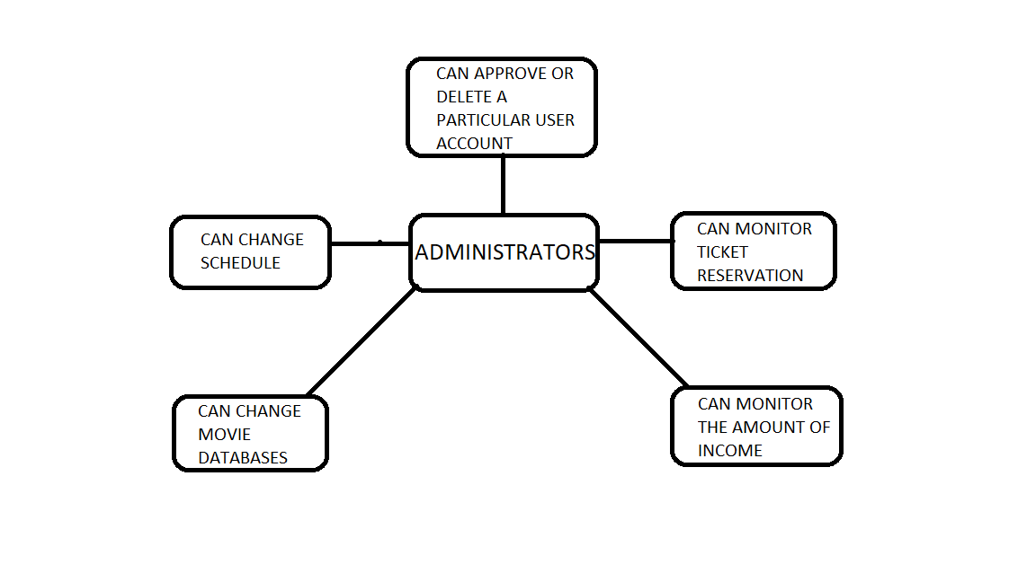

FOR USERS

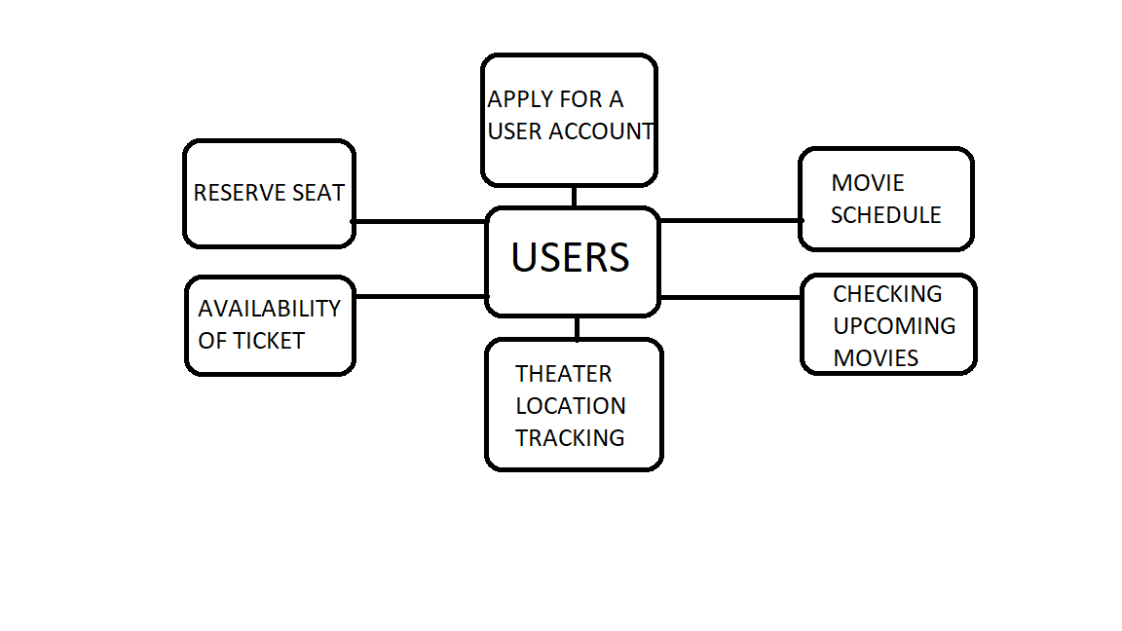

Data Collection Form Smart Movie Theater Management

|  |  |  |
| --- | --- | --- |
| Role : | User ID : | Phone : |

|  |  |
| --- | --- |
| Name : |  |
| Address : |  |
| Profession : |  |

* FAQs about MOVIE THEARER

|  |  |
| --- | --- |
| 1. | Tell us a suggestion you have made that should be implemented in this Theater Management System ? |
|  |  |
| 2. | What/how do you know about the movies that gets released ? |
|  |  |
| 3. | How do you want to see this system ? What will be beneficial for you? |
|  |  |
| 4. | Do you have any questions to ask us ? |
|  |  |

* General Questions and answers :

|  |  |
| --- | --- |
| 1. | Who are engaged with it by whom ? |
| Answer : |  |
| 2. | Is there any online process ? |
| Answer : |  |
| 3. | How people are concerned about this ? |
| Answer : |  |
| 4. | What are the problems we have to face while going to see a movie? |
| Answer : |  |
| 5. | Do you think that digitization is the solution of these existing problems ? |
| Answer : |  |
| 6. | Can our system help for this purpose ? How ? |
| Answer : |  |
| 7. | What are the problems we have to face to implement our system in real life ? what are challenges of our system ? |
| Answer : |  |
| 8. | Do you think we have to add more questions in our research ? What are the questions ? |
| Answer : |  |

Comment/opinion about this survey :